General Welfare Requirement: Safeguarding and Promoting Children's Welfare
The provider must take necessary steps to safeguard and promote the welfare of children.

Gorran Pre School
Safeguarding Children
1.4 Confidentiality and client access to records

Policy statement
Definition: 'Confidential information is information that is not normally in the public domain or readily available from another source, it should have a degree of sensitivity and value and be subject to a duty of confidence. A duty of confidence arises when one person provides information to another in circumstances where it is reasonable to expect that the information will be held in confidence.' (Information Sharing: Guidance for Practitioners and Managers (DCSF
2008))
At Gorran Pre-School Hoglets, staff and managers can be said to have a 'confidential relationship' with families. It is our intention to respect the privacy of children and their parents and carers, while ensuring that they access high quality early years care and education in our setting. We aim to ensure that all parents and carers can share their information in the confidence that it will only be used to enhance the welfare of their children. There are record keeping systems in place that meet legal requirements; means of storing and sharing that information take place within the framework of the Data Protection Act and the Human Rights Act.

EYFS key themes and commitments
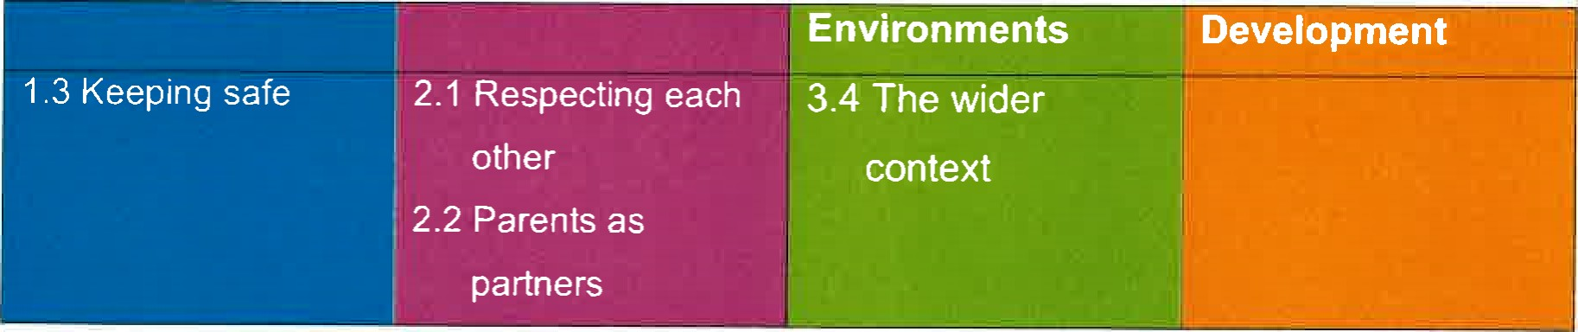

Confidentiality procedures
- Gorran Pre-School Hoglets always check whether parents regard the information they share with us to be regarded as confidential or not.
Some parents sometimes share information about themselves with other parents as well as staff; the setting cannot be held responsible if information is shared beyond those parents whom the person has 'confided' in.
- Information shared between parents in a discussion or training group is usually bound by a shared agreement that the information is confidential to the group and not discussed outside of it.
- Gorran Pre-School Hoglets informs parents when we need to record confidential information beyond the general personal information we keep (see our record keeping procedures) - for example with regard to any injuries, concerns or changes in relation to the child or the family, any discussions with parents on sensitive matters, any records we are obliged to keep regarding action taken in respect of child protection and any contact and correspondence with external agencies in relation to their child.
Gorran Pre-School Hoglets keeps all records securely (see our record keeping procedures).

Client access to records procedures
Parents may request access to any confidential records held on their child and family following the procedure below:
- Any request to see the child's personal file by a parent or person with parental responsibility must be made in writing to the setting leader or manager.
Gorran Pre-School Hoglets leader informs the chairperson of the management committee and sends a written acknowledgement.
- Gorran Pre-School Hoglets commits to providing access within 14 days, although this may be extended.
- Gorran Pre-School Hoglets leader and chairperson of the management committee prepare the file for viewing.
All third parties are written to, stating that a request for disclosure has been received and asking for their permission to disclose to the person requesting it. Copies of these fetters are retained on file.
'Third parties' include all family members who may be referred to in the records.
It also includes workers from any other agency, including social services, the health authority, etc. It is usual for agencies to refuse consent to disclose, preferring the individual to go directly to them.
When all the consents/refusals to disclose have been received these are attached to the copy of the request letter.
A photocopy of the complete file is taken.
Gorran Pre-School Hoglets leader and chairperson of the management committee go through the file and remove any information which a third party has refused consent to disclose. This is best done with a thick black marker, to score through every reference to the third party and information they have added to the file.
What remains is the information recorded by the setting, detailing the work initiated and followed by them in relation to confidential matters. This is called the 'clean copy'.
The 'clean copy' is photocopied for the parents who are then invited in to discuss the contents. The file should never be given straight over, but should be gone through by the setting leader, so that it can be explained.
Legal advice may be sought before sharing a file, especially where the parent has possible grounds for litigation against the setting or another (third party) agency.
All the undertakings above are subject to the paramount commitment of the setting, which is to the safety and well-being of the child. Please see also our policy on child protection.

Legal framework
Data Protection Act 1998
Human Rights Act 1998

Further guidance
Information Sharing: Guidance for Practitioners and Managers (DCSF 2008)

This policy was adopted at a meeting of

Held on
Date to be reviewed
Signed on behalf of the management committee
Name of signatory
Role of signatory (e.g. chair)
Gorran Preschool name of setting

October 2019 (date)

October 2020 (date)

Michelle Beard

Preschool Leader/Nominated Person

